dated 11/05/2022

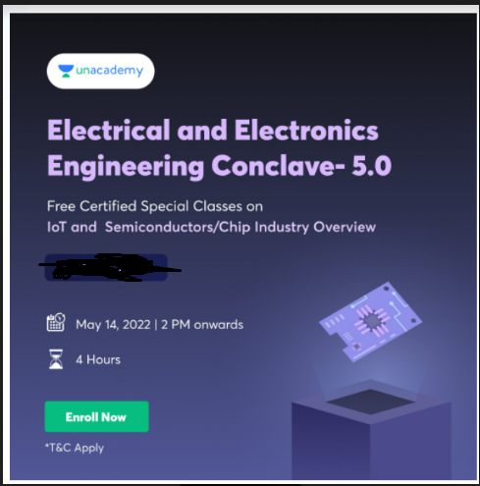

A webinar ON iot and semiconductors/chip industry
Training and Placement Office is organizing a Webinar for Electrical & Electronics students ( 2nd, 3rd & Final Year) On 14/05/2022 by UNACEDMY. The event will be coordinated by TPO and HOD(EE) & HOD(ECE)

Day : 14/05/2022 (SATURDAY)

Duration : 4 Hr. (2 PM -6 PM)


Co-Ordinators : Ms. Devjani , Ms. Akanksha | TPO : Swati Bhardwaj

